Ser1
Prerequesit – dc
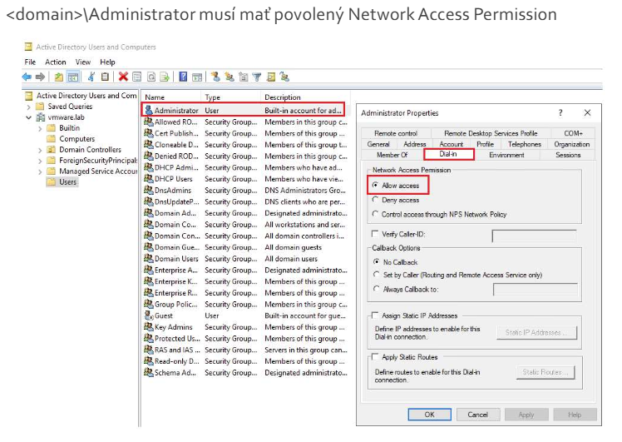
- Zmena nic nazvov
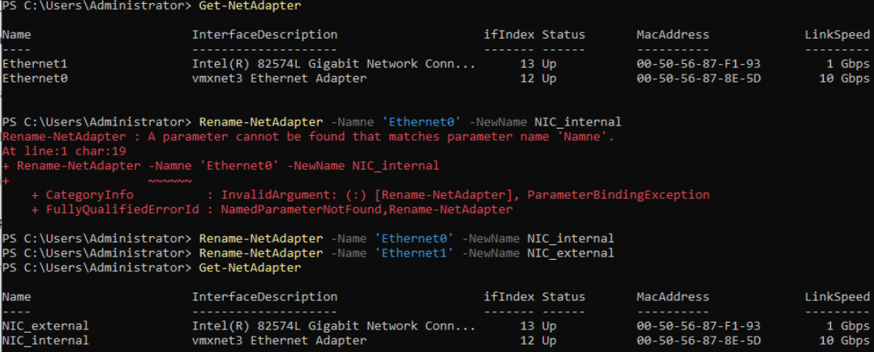
- Vypnutie registracie DNS a netbios na externom nic
Tam jak su nic-ky ->> propertie ->> tcp ipv4 ->> advanced
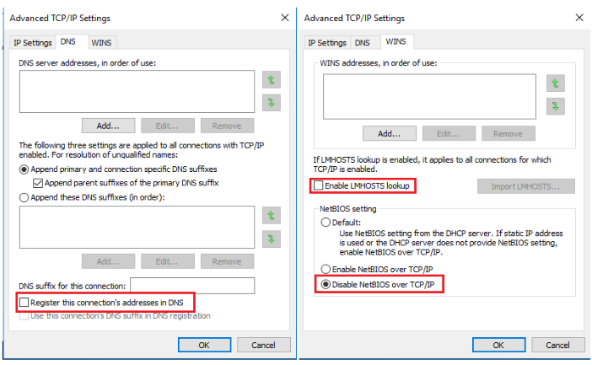
- Zapnutie registracie DNS a netbios na internom nic
Ideme tam jak nic external
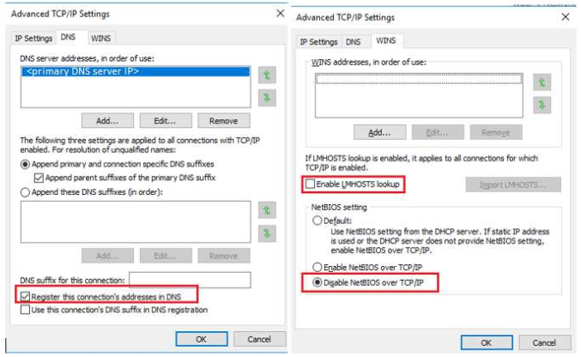
- Zapnutie FW na vsetkych FW profilov srv1
Get-NetFirewallProfile | ft -AutoSize
Skipujem bo tam neni postup a zevraj aj bez firewall to bude fungovat
- Instalacie role
Otvori Server Manager → “Manage” → Add Roles and Features
Select server → vyber svoj server
Select server roles:
→ zaškrtni Remote Access
Klikaj “Next” až po Role Services, potom vyber:
- DirectAccess and VPN (RAS)
- (voliteľne aj “Routing”, ak chceš NAT alebo route)
Dokonči inštaláciu a reštartuj server (ak vyžiada).

Alebo cez command: Install-WindowsFeature -Name DirectAccess-VPN -IncludeAllSubFeature -IncludeManagementTools
- Routing and remote access
Vybrat VPN access, finish, start
- Konfiguracia
Properties ->> ipv4 ->>
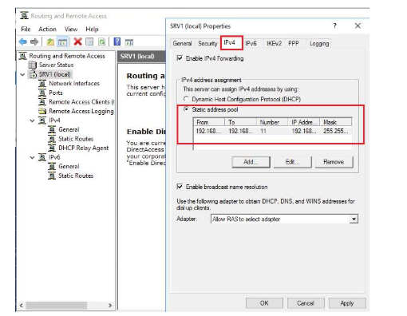 ip range 192.168.211.50-60
- Konfiguracia access policy cez NPS

